

Name: Muhammad Usama Bilal
Roll Number :CSI-B1-460
INSTRUCTOR: MUHAMMAD SAAD
Date: 8-3-2026

Task: Virtualization and Topology Set Up
Objective The primary goal of this task is to establish a secure and isolated Purple Team laboratory environment. By utilizing virtualization technology, the environment is designed to contain both an attacker machine and a victim machine. This setup facilitates the simulation of cybersecurity scenarios within an internal network, ensuring that all activities remain contained and do not interfere with external production systems.
Tools and Environment
- Virtualization Platform: VMware Workstation
- Attacker Machine: Kali Linux
- Victim Machine: Windows 10
Laboratory Architecture The network topology is configured using a Host-Only architecture to ensure complete network isolation from the outside world.
- Network Connection: VMnet1
- IP Addressing Scheme:
  - Attacker Machine (Kali Linux): 192.168.72.128
  - Victim Machine (Windows 10): 192.168.72.129
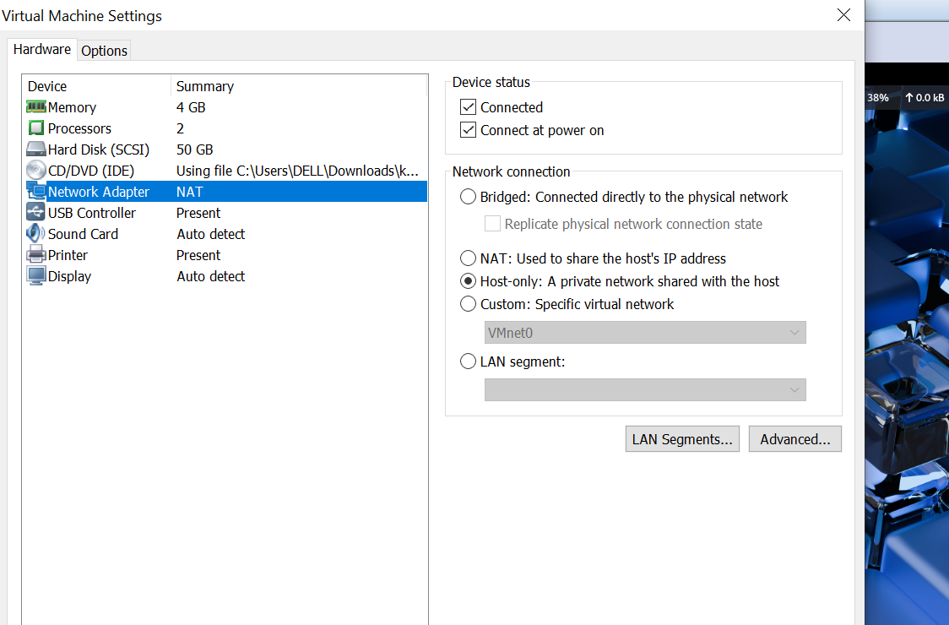
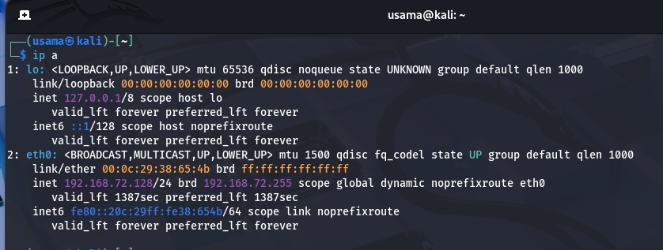
Implementation and Configuration
- Virtual Machine Creation: Two distinct virtual machines were created within VMware Workstation. Hardware resources, including RAM, CPU, and Disk, were allocated appropriately for the specific operating systems (Kali Linux and Windows 10).
- Network Setup: The network adapters for both machines were configured to use the Host-Only connection mode (VMnet1). Static IP addresses were manually assigned to each machine to ensure persistent and predictable communication paths.
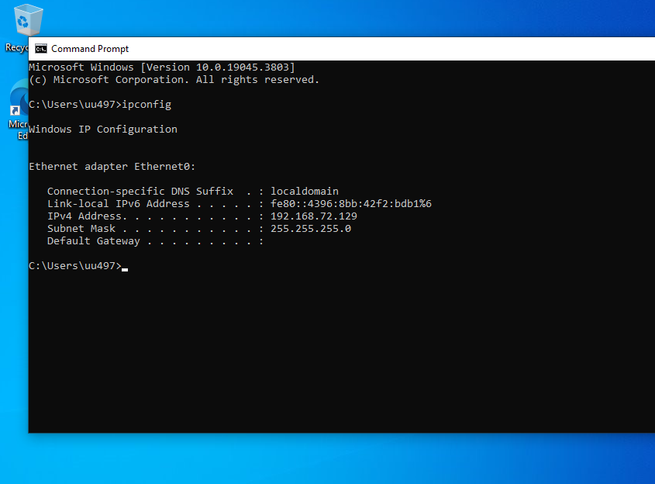

Connectivity Verification To validate the network configuration, a connectivity test was performed. The ping command was executed from the attacker machine to the victim machine's IP address (192.168.72.129).
- Result: The test successfully demonstrated that the machines could communicate. Data packets were sent and received with 0% packet loss, confirming that the internal link is active and functioning correctly.
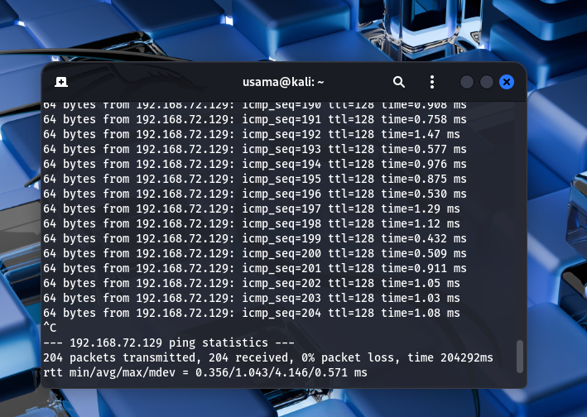
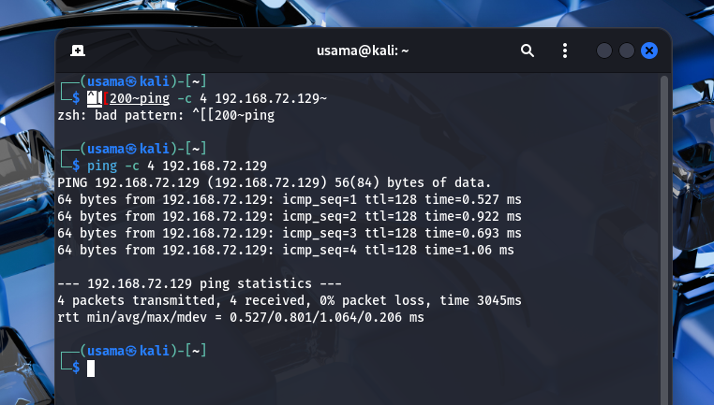

Task 2: Packet Analysis and Protocol Deep Dive
Objective
The primary objective of this task was to analyze network traffic and understand the fundamental mechanics of data transmission across a network. This phase focused on capturing live packets, observing the communication flow between an attacker and a target system, and identifying the structural components of network protocols.
Tool Used: Wireshark
For this analysis, Wireshark was utilized as the primary network protocol analyzer. Wireshark provides deep visibility into the network layer, allowing for the real-time capture and inspection of individual data packets.
Packet Capture Methodology
The packet capture was performed on the Kali Linux machine using the following systematic approach:
- Interface Selection: The active network interface (eth0) was selected, which was configured on a Host-Only network to isolate the lab traffic.
- Traffic Generation: To create observable data, the Ping utility was used to send ICMP echo requests between the Kali Linux attacker machine and the Windows 10 target machine.
- Protocol Filtering: A display filter for ICMP was applied within Wireshark to isolate the relevant ping traffic from background network noise.

Results and Technical Analysis
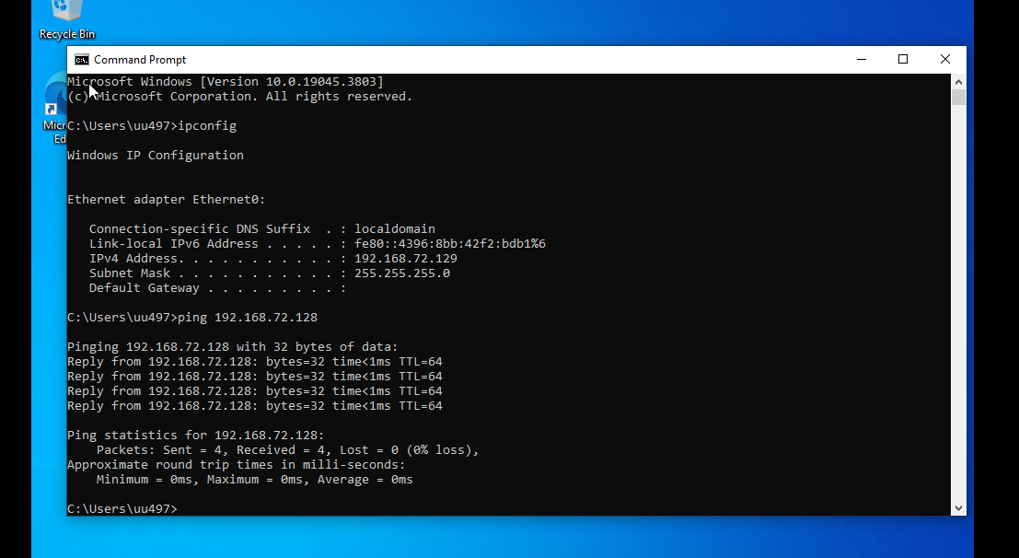
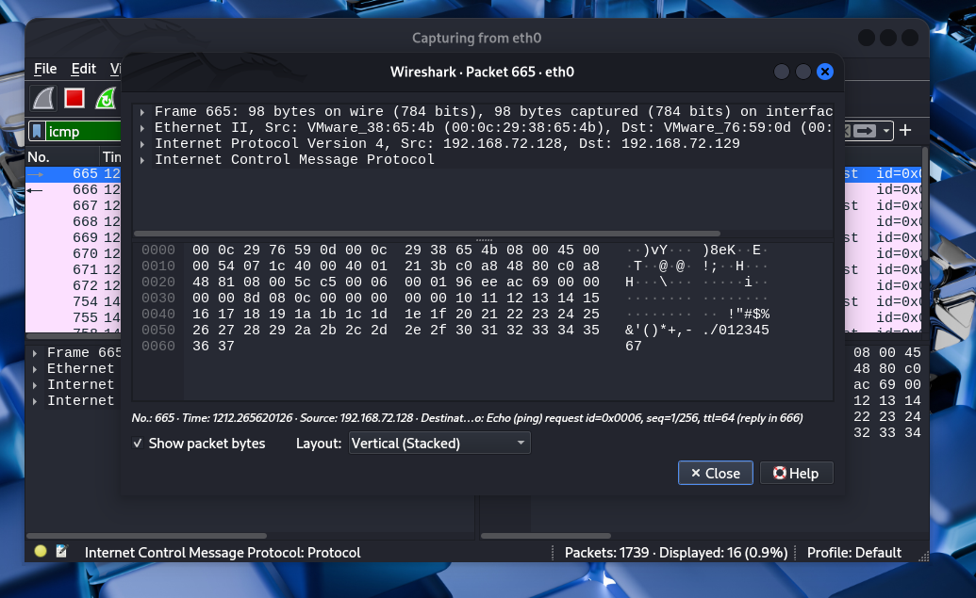
Upon executing the connectivity test, Wireshark successfully captured the interaction between the two virtual machines:
- Traffic Source & Destination: The capture shows packets originating from the Kali Linux IP (192.168.72.128) and reaching the Windows 10 target IP (192.168.72.129).
- ICMP Echo Process: The "Info" column identifies the standard ICMP handshake: an Echo (ping) request followed immediately by an Echo (ping) reply from the target.
- Protocol Header Inspection: By selecting a specific packet, the Internet Control Message Protocol headers were analyzed. The "Type 8" (Request) and "Type 0" (Reply) codes confirm a successful bi-directional communication channel.
- Data Payload Analysis: The Hexadecimal view reveals the data payload (e.g., 10 11 12 13...), which serves as a placeholder to verify that the data sent by the source is exactly what is received by the destination.

Conclusion :
The Purple Team laboratory environment has been successfully established, providing a robust and safe sandbox for security simulations. This task successfully demonstrated the network visibility required for professional security operations by capturing and analyzing ICMP traffic between the machines. The implementation confirms that the systems can communicate effectively via the Host-Only network while remaining completely isolated from external threats.

